1. Attach the PiFace to the your Pi, connect it to the network and run the PiFace Emulator to check that last week’s install is working.

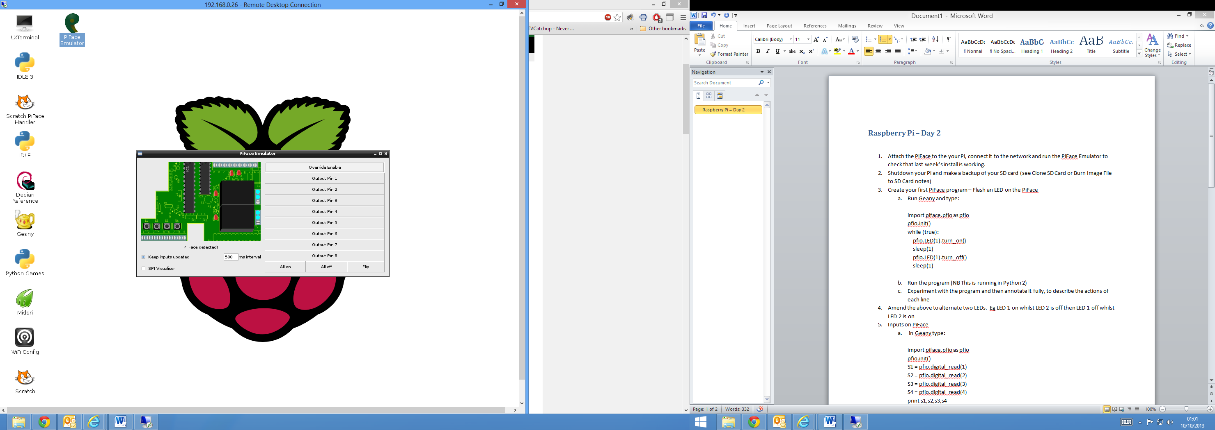

1. Shutdown your Pi and make a backup of your SD card (see Clone SD Card or Burn Image File to SD Card notes)
2. Create your first PiFace program – Flash an LED on the PiFace
   1. Run Geany and type:  
        
      import piface.pfio as pfio  
      pfio.init()  
      while (true):  
       pfio.LED(1).turn_on()  
       sleep(1)  
       pfio.LED(1).turn_off()  
       sleep(1) 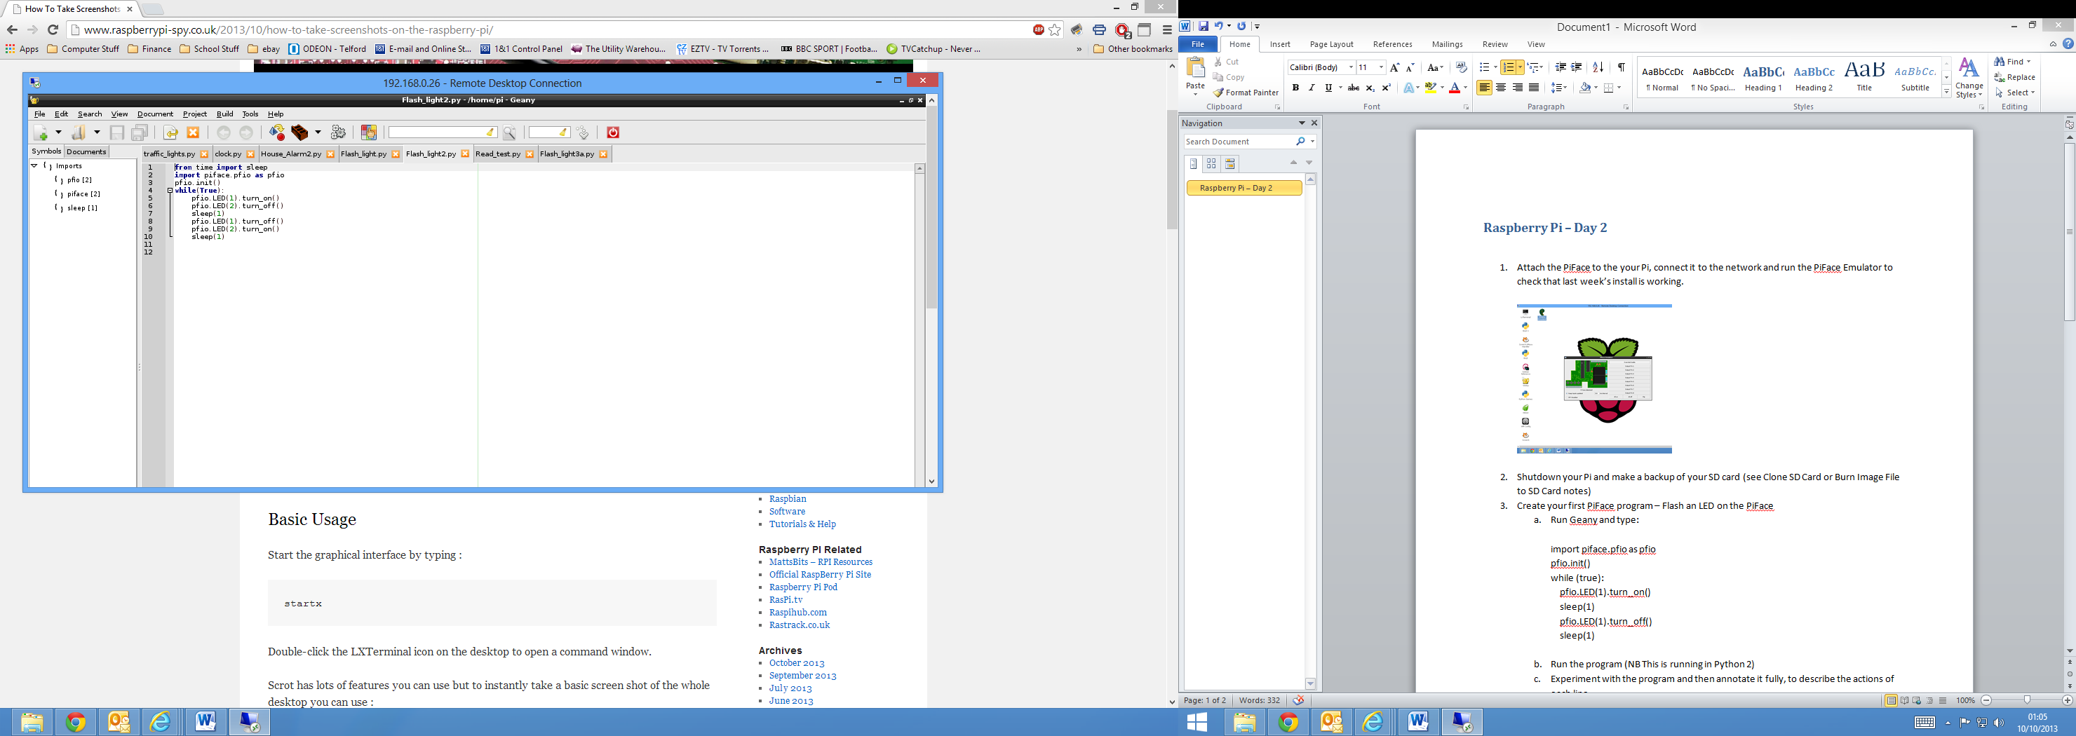
   2. Run the program (NB This is running in Python 2)
   3. Experiment with the program and then annotate it fully, to describe the actions of each line
3. Amend the above to alternate two LEDs. Eg LED 1 on whilst LED 2 is off then LED 1 off whilst LED 2 is on
4. Inputs on PiFace
   1. in Geany type:  
        
      import piface.pfio as pfio  
      pfio.init()  
      S1 = pfio.digital_read(1)  
      S2 = pfio.digital_read(2)  
      S3 = pfio.digital_read(3)  
      S4 = pfio.digital_read(4)  
      print s1,s2,s3,s4  
      

Hold down some of the buttons on the PiFace and run the program

* 1. Hold down some of the buttons on the PiFace and the run the program
  2. Amend the program so that it will continue to loop back forever (see the program above).
  3. Change the program in step c so that it will stop when switch 1 is pressed
  4. Change the program in step d so that it will stop when  
      s1 AND s4 are pressed together. (Hint 1 – s1,s2,s3,s4 must have initial values. Hint 2 – the loop will continue whilst s1 is not equal to 1 OR s4 is not equal to 1). Not equal is !=



1. Draw a flowchart to describe the process for a simple traffic light controlling traffic at a Road Works. (Red, Red&Amber, Green, Amber and back to Red). Use LED 8 as Red, 6 as Amber and 4 as Green
2. Write the program to operate on PiFace for the above traffic light
3. Write a program that turns on an alarm when a switch is triggered: A simple house alarm

